**While considering the scope of the individual functionalities draw the use case diagram for each of it.**

Table of Contents

1.) Use case Diagram for the Expense Enigma App 2

1.1) Actors 2

1.2.) Use Case 2

2.) Description 3

# Use case Diagram for the Expense Enigma App

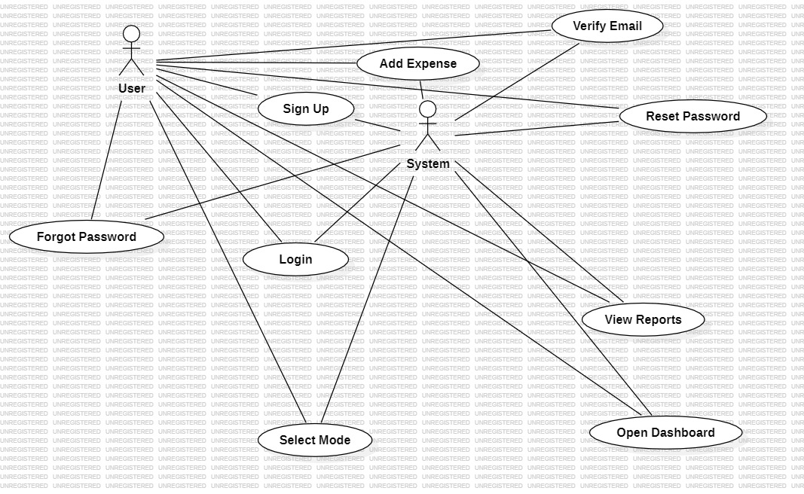

Figure 1: Use Case diagram for Expense Enigma Web App

## Actors

* + - User
    - System

## 1.2.) Use Case

* Select Mode
* Login
* Forgot Password
* Reset Password
* Sign Up
* Verify Email
* Open Dashboard
* Add Expense
* View Reports

# Description

*In the expense sharing app, when the user opens the mode selection web page, they encounter two modes: normal mode and voice recognition mode. If the user clicks on normal mode, a login page appears where the user is prompted to enter their email and password. After entering the credentials, the user clicks on the login button, leading them to the dashboard.*

*In the event that a user forgets their password, they can initiate the password reset process. The user is required to enter their email, and a verification code is sent to their email address. After receiving the verification code, the user enters it and then proceeds to reset their password. Once the new password is set, the user can log in using the updated credentials.*

*For users who do not have an account, they can click on the signup option. During signup, the user is prompted to provide details such as their name, email, password, and budget limit. After entering this information, a verification code is sent to the user's email. Upon entering the verification code and clicking on signup, the dashboard opens. Initially, the spending limit is set to 0, and the budget limit is based on the user's input.*

*Within the app, there is a button to add expenses. When the user incurs an expense, they enter the expense details, including the amount and description. The app deducts the entered amount from the budget. After adding the expense, a chart displaying the budget limit and spending limit is updated.*

*If a user wishes to review their transaction history, they can click on the report option. This allows the user to access and view their transaction report*.